Ideagen Workforce Safety
Author Bek Osmond
Date 25/09/2025
Registration Site Procedure
Maaden Gold

Site 1: Ad Duwayhi (ADW)
Site 2: Open Pit (ADW)
Site 3: Processing Plant (ADW)


Contents
SUMMARY 2
Site Contacts 2
Mobilisation Types 3
Mobilisation Fees 6
Worksite Information 6
Hardware on Site (If applicable) 7
Worksite Safety Modules used by site 7
Ideagen Learning 7
Damstra Forms 7
Site Rules & Guidelines 7
Processing Registrations 8
Examples of Site Requirements 8
Additional Information – Steps for GST 8

SUMMARY
Ideagen and Maaden have agreed to implement ‘Workforce Safety’ across certain Maaden mining sites. This solution will be piloted at Maaden Ad Duwayhi with the aim to replicate and refine the standardized global approach to onboarding workers to Maaden sites. The result is a single source of truth for all information related to Maaden’s employees, contractors, skills, competencies, training courses, and training records.
For additional Context – the scope of this Client includes 3 Separate Sites – each run by separate entities
Site 1: Ad Duwayhi (ADW) – is run by the Principal Company: Ma'aden Gold and Base Metals (MGBM)
Site 2: Open Pit (ADW) – is run by a Contracting Company: JACK RIJK AL-RUSHAID CO.LTD
Site 3: Processing Plant (ADW) – is run by a Contracting Company: DRA SAUDI ARABIA LLC

IMPORTANT: All workers must be mobilized at Ad Duwayhi (ADW), before then can work at the Open Pit or Processing Plant

Industry: Gold Mining
Geographical Location: Saudi Arabia
Time Zone: Arabia Standard Time (AST)
Operating Hours: Sunday – Thursday -closed on Fridays
Language: English
Production Instance: AU
Account Manager: Nicholas Walker
CSD: Martina Simmons
Integrations:
There will be manual integration only during Phase one of this project- where a flat csv file will be provided to import Permanent Workers
Phase two of this project will include a 3rd part integration with Element
Contractors will utilize the Company Portal

Site Contacts
The primary contact is someone you are in constant contact with as they are involved with the site mobilisation process on site and run/manage Ideagen Workforce Safety for the worksite:
Site 1: Ad Duwayhi (ADW)
Name: Benjamin Andrews
Position: Principal Specialist, Technical Training
Email: AndrewsB@maaden.com.sa
Phone: NA

The secondary contact is someone you are in regular contact with as they are involved with the site mobilisation process on site:
TBC
This is an additional site contact, specific to Qualifications/Job Titles queries on site: (if applicable)
TBC

Mobilisation Types
IMPORTANT: All workers must be mobilized at Ad Duwayhi (ADW), before then can work at the Open Pit or Processing Plant

Site 1: Ad Duwayhi (ADW)
The following are the different mobilisation types that are available for use to become inducted for Ad Duwayhi (ADW)and gain site access:

ADW Maaden Mobilisation
Most subcontracting companies will use this mobilisation type for their workers. This mobilisation type is publicly available to all companies in their Company Portal accounts.

ADW Permanent Maaden Mobilisation
This mobilisation type is used by Ad Duwayhi (ADW) employees
The companies with access to this mobilisation type are:
Base Metals & New Minerals BU
Requirements per mobilisation Type
The following information shows what must be provided/completed for each mobilisation Type for mobilisation to become active and for the worker to gain site access.

ADW Maaden Mobilisation
Pre Mobilisation:
- Maaden ADW License Fee (Skill Code: ADW FEE) – billed to site
- Iqama or national identification
- Medical certificate
Post Mobilisation:
- ADW site induction
- Life saving rules

ADW Permanent Maaden Mobilisation
Pre Mobilisation:
- Maaden ADW Permanent License Fee (Skill Code: ADW PERMFEE) – billed to site
Post Mobilisation:
- ADW site induction
- Life saving rules
Site 2: Open Pit (ADW)
The following are the different mobilisation types that are available for use to become mobilised for Open Pit (ADW)and gain site access:

Jac Rijk Open Pit
Most subcontracting companies will use this mobilisation type for their workers. This mobilisation type is publicly available to all companies in their Company Portal accounts.

Permanent - Jac Rijk Open Pit
This mobilisation type is used by Ad Duwayhi (ADW) employees
The companies with access to this mobilisation type are:
Base Metals & New Minerals BU

Requirements per mobilisation Type
The following information shows what must be provided/completed for each mobilisation Type for mobilisation to become active and for the worker to gain site access.

Jac Rijk Open Pit
Pre Mobilisation:
- Maaden ADW License Fee (Skill Code: ADW FEE) – billed to site
- Iqama or national identification
- Medical certificate
- ADW Site Induction
Post Mobilisation:
- Open Pit Induction
Permanent - Jac Rijk Open Pit
Pre Mobilisation:
- Maaden ADW Permanent License Fee (Skill Code: ADW PERMFEE) – billed to site
- ADW Site Induction
Post Mobilisation:
- Open Pit Induction
Site 3: Processing Plant (ADW)
The following are the different mobilisation types that are available for use to become mobilised for Processing Plant (ADW) and gain site access:

DRA Processing
Most subcontracting companies will use this mobilisation type for their workers. This mobilisation type is publicly available to all companies in their Company Portal accounts.

Permanent - DRA Processing
This mobilisation type is used by Ad Duwayhi (ADW) employees
The companies with access to this mobilisation type are:
Base Metals & New Minerals BU

Requirements per mobilisation Type
The following information shows what must be provided/completed for each mobilisation Type for mobilisation to become active and for the worker to gain site access.

DRA Processing
Pre Mobilisation:
- Maaden ADW License Fee (Skill Code: ADW FEE) – billed to site
- Iqama or national identification
- Medical certificate
- ADW Site Induction
Post Mobilisation:
- DRA Safety Induction
Permanent - Jac Rijk Open Pit
Pre Mobilisation:
- Maaden ADW Permanent License Fee (Skill Code: ADW PERMFEE) – billed to site
- ADW Site Induction
Post Mobilisation:
- DRA Safety Induction

Mobilisation Fees
Contractor fees | Permanent fees
Maaden ADW Licence Fee – billed yearly | Maaden ADW Permanent Licence Fee – billed yearly

Worksite Information
The following information is additional helpful information regarding the site and its mobilisations
Site Address: Makkah Province 13784
Saudi Arabia

Site Search Strings:
Site 1: Ad Duwayhi (ADW)
MAADEN ADW
Site 2: Open Pit (ADW)
MAADEN OP
Site 3: Processing Plant (ADW)
MAADEN PP
Lockout period: 0 days
Card Printing: No cards for phase one

Hardware on Site (If applicable)
No hardware for phase one

Worksite Safety Modules used by site
Ideagen Workforce Safety inclusive of Workforce Management, Company Portal (Contractors) Ideagen Learning, Forms & Insights

Ideagen Learning
Site 1: Ad Duwayhi (ADW)
URL:https://ma-adw.velpic.net

Site 2: Open Pit (ADW)
URL: https://ma-adw-op.velpic.net/

Site 3: Processing Plant (ADW)
URL: https://ma-adw-pp.velpic.net

Damstra Forms
URL: https://maaden.damstraforms.com

Site Rules & Guidelines
This client has opted to use the following Workforce Safety Functionality
- Org-wide Skills – all skills have been created as organisation-wide skills – all skills have been skill coded
- Skills with Requirments – this client is using this function for trainign skills that contain, theory and VOC components
- Self Configuration of Skills – this client will be self configuring their own skills during phase one – they may also utilise self configuration for job titles and mobilisations after further training
- Custom User Permissions – this client has has custom user roles created specially for their needs – these are:
Level 1 - Read only – level 1
Level 2 - Data Entry – level 2
Level 3 – Instructor – level 3
Level 4 - Site Administrator – level 3
Level 5 - Site Administrator +PI - level 3
Level 6 - Org-Wide – level 3

- Custom Data Types – this client has added two addional data types that will show on a employee profile – once the Iquama/National ID is added to a profile it will override the Damstra ID
- Element ID
- Iqama/National ID
*If you ever need to upload these custom fields in bulk, below are the database numbers:
2300 - Element ID
2301 - Iqama/National ID

Processing Registrations
All sites will utilise post rules within their mobilisation rules, this means that the site is responsible for uploading these skills to profiles.
Mobilisation will not be activated until all pre & post rules have been met.

Examples of Site Requirements
The following are examples of some of the Site Requirements needed to be uploaded in the Company Portal for the Maaden Mobilisation, to assist those processing the documents to understand what is required.
Skill: Global Qualification: Iqama/National ID
Important Step: when processing this skill, you will need to enter the IQAMA number in the custom data field on a employee’s profile
What is an Iqama?
An Iqama, often referred to as a “residence permit“, is a legal document that provides expatriates the right to live and work in Saudi Arabia. It is a small laminated card, similar in size to a credit card, containing personal details, profession, and other pertinent information.
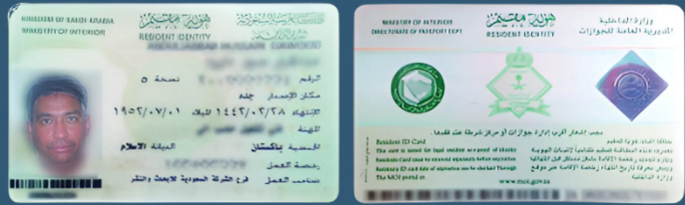
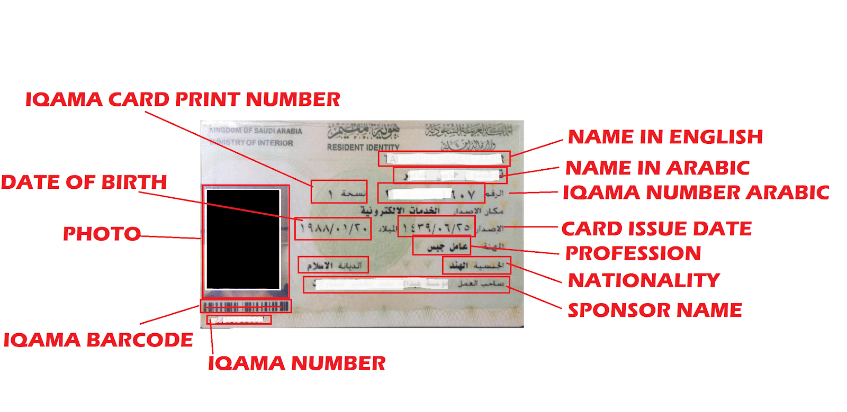
Medical Certificate- waiting on an example of this document

Additional Information

